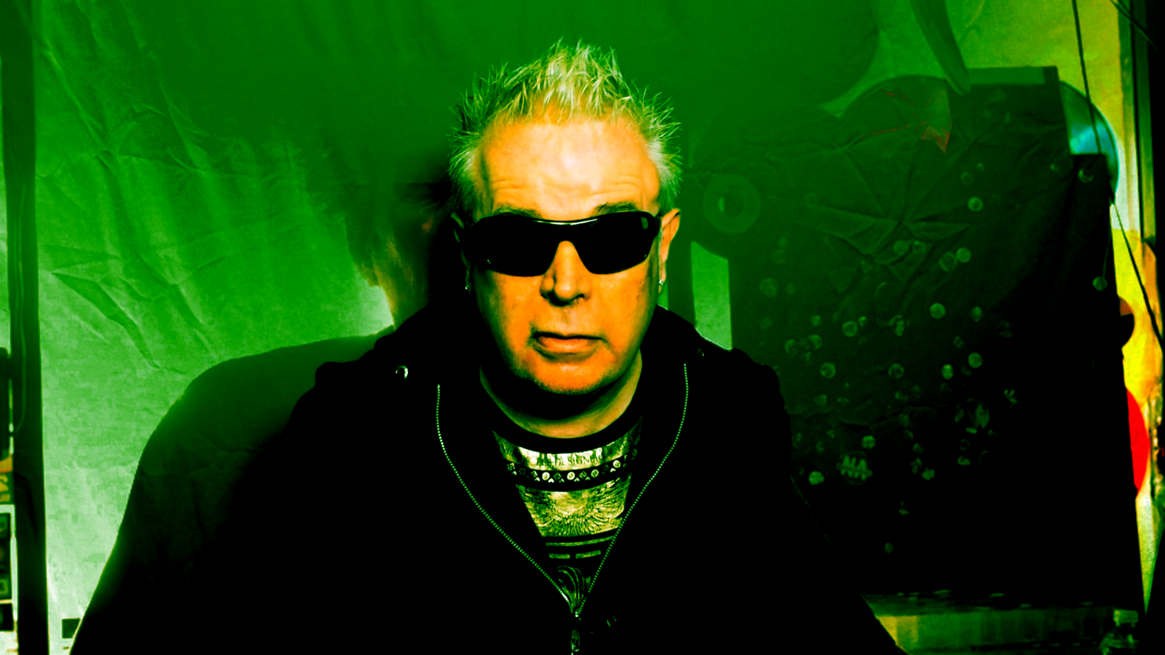
Producer & Blockhead Mike Bennett together with Friedbanana make punk vegan slasher movie.
Mike Bennett cut his teeth in the music industry at the age of ten playing in local punk bands in the 70’s, and by the age of 18 trained as an actor at Richmond drama school prior to going to Oxford whilst working as a writer for the BBC for the primary science curriculum.
Continuing to act in the West End and on TV play in an assortment of punk & alt pop groups. He wrote many scripts for the likes of the Muppets & children ITV where he was script writer in residence for 3 years.
As well as penning several plays in the West End including Poezest (Bloomsbury theatre), Safety in numbers (Mermaid theatre ) & Blockbuster (Player theatre) he wrote for many comedians including Rik Mayall , Phil Cool, Franky Howard , Jim Bowen & Bobby Davro & others.
Being an incurable insomniac Mike found time to write & produce many albums for the likes of Creation records, Trojan records, Cherry Red & Universal to name a few. His credits include The Fall, Toyah, Gregory Isaacs, The Specials, Hazel O’Connor, Wish Bone Ash, Emmerson Lake & Palmer , Dennis Brown & Ian Brown with whom he composed the single Golden Gaze.
Although Mike has written many Westend & regional musicals it was not until he got the chance to write a punk rock slasher movie in California that he was able to combine his record production with left field drama.
Unfortunately in California things went horribly wrong. Mike, who has just come off stage at Rebellion festival Winter gardens, where he was performing as the new lead singer for The Blockheads says :
“I was at NAMM music festival at Anaheim stadium California where I lived briefly & went to an iconic record store in Huntington Beach with my lawyer Terry Marsh & an actor called Steve Watson. I went along with them to the store as we were all vinyl junkies but they had something else in mind for me & revealed their plan whilst I was flicking through the Punk & Goth section at the amazing antiquated record store .
Terry & Steve explained they wanted me to write a documentary about Vinyl Solutions ( that’s the name of the iconic store.)
I gave them a flat NO explaining that I didn’t write documentaries. However on learning that the owner was celled Drak I suggested that I combine the vinyl documentary with a horror film treatment then would make we write vegan vampires into the Vault of the store.
This is how I came to write Back to Drak.”
The team regrouped in England, knocked up a treatment & flew back with a cast of musicians, actors & crew and that’s where things started to go horrifically wrong!.
Everything from an actor being arrested on the airplane for throwing prosecco around , it didn’t help as it was Twin Towers memorial day on American airlines. He literally had guns pointed to his head at the airport & spent 3 days in a cell before being deported back to the UK .

Other disasters included one of the American actresses collapsing on stage on the second day & cracking her head open. She was carted off to hospital at a cost of $4000, when she was identified at hospital by her passport ID. It was revealed that she had signed the film contract under a fake name, so our insurance was marginalized to say the least.
One of the English musicians from Kavanagh literally witnessed an axe killing & ended up receiving counselling by Siamese twins (it could only happen in America!). To add insult to injury a certain member of the production team & one of the UK actresses used what was left of the budget to shoot a hard-core porn film.
Anyway to cut a long story short we came back to the UK & were faced with Covid & the lockdown that went with it. Also during lockdown we realised that the maverick guy on the production team & the porn artist had stolen most of the footage.
All that we had left was the stuff that was left on the cutting room floor. Not feeling completely defeated an idea popped into my miniscule but active mind. Realising that we had a lot of fantastic musicians involved in the film & sound track including Peter Hook, Melanie Williams, Fuzzbox , Glenn Matlock, The Troggs, Brian May, the Specials & Darryl Hannah (yes she sings!) And John Otway who also makes a brilliant actor in the film. He plays a bemused record collector who witnesses a gimp incident & gets murdered by Maggie from Fuzzbox who kills him with needles whilst balancing a live squirrel on her head.
At this stage I turned my attention to Dylan Roarke at Friedbanana design as he has been brought on board to piece everything together with his own unique vision. Dylan had worked with Mike Bennett at a record label run by the father of Plan B while doing artwork for the Stranglers, Blondie and Hazel O’Connor As for the film itself it’s very stylised. Dylan adds “Well, we kinda created our own style guide with this film - If life was one long pop video then this represents that but to horrific proportions. It’s a chat show, within a chat show, within a movie and a documentary about a movie that went wrong. It’s B-movie bedlam. They were punch-ups arguments and lots and lots of rock ‘n’ roll which is what I really like about this film. The people that go in and out vinyl vinyl solution are just fabulous”.
So anyway this sort of explains how Vegan Vampire From Zorg was born out of Back to Drak.
Usually a sound track is lead by the drama in the film, but to some extent the drama is lead by the fantastic musicians involved and there are some amazing musicians involved .
What we’ve got here is a film made with the DIY ephos of punk & a surreal meander into B Movie themes such as Vampire Aliens, Serial Killers & at one point even Glampires.
Its also based on the truth & is part of a “shockumentary” drama salvaged from the cutting room floor & equally important incredible music.
So I like to think there is something for everybody.
Vegan Vampires From Zorg receives its non cinematic premier at York’s noted gig venue The Victoria Vaults. This Halloween special is an immersive experience where the audience are able to re-edit the movie.
We’ve got Fuzzbox & we’re going to use it will be supplying original improvised music score through out the experience.
John Otway will be appearing live for the after show party playing his unique set along side other amazing musicians .
The audience also get to drink a luminous green cocktail with stars such as Sub Sub legend Melanie Williams .
The film will be playing unconventional venues to be announced including a Dungeon, a Bus, a Cave & a notorious burial site.
In the new year the production company have signed a six cinema deal. Also it will be digitally available on Amazon Prime & other I media stores via OneMediaIP via Pinewood studios.
The box set with vinyl and book to be available via Gonzo Media – publication to be announced.
http://www.veganvampiresfromzorg.com/

Vegan Vamps Promo:
https://youtu.be/Fe_xaSVW5mw

Root 66s: Melanie Williams
https://youtu.be/vuqH6mdm1Mo

The Healer: Melanie Williams Peter Hook
https://youtu.be/WTzEM3-jehk

Wild Thing – Troggs ft Brian May
https://vimeo.com/585389686

I am Mark E smith
https://vimeo.com/580267117

Heterochromia – Melanie Williams Ft Peter Hook (Long Mix)
https://vimeo.com/724762268

